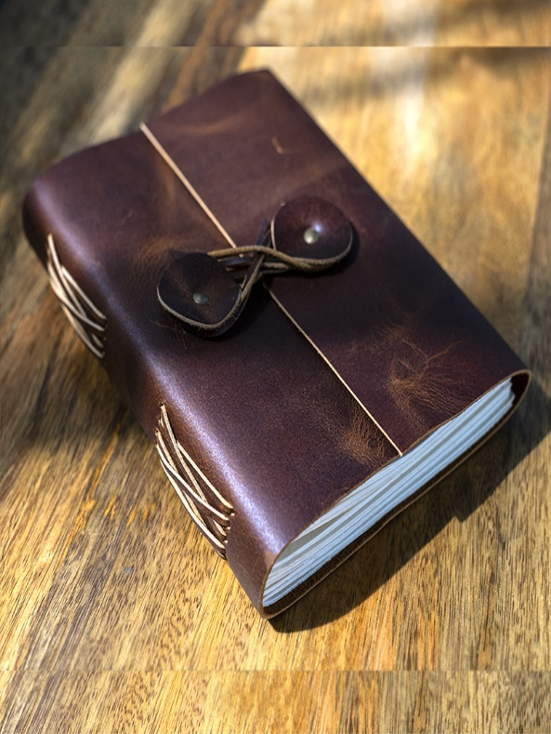LEATHER JOURNAL  
RYANA CALENDARS is selling wonderful LEATHER journals! at reasonable prices. It contains beautiful and designable covers!

RS 999